PANIMALAR ENGINEERING COLLEGE

AI POWERED NUTRITION ANALYZER FOR FITNESS ENTHUSISTS

A PROJECT REPORT

Submitted by

SYED SOHAIL AHMED B
VIJAY P K
VIJAY M P
THARUN E

in partial fulfillment for the award of the degree
of

BACHELOR OF ENGINEERING
in

COMPUTER SCIENCE AND ENGINEERING

Project Report

- INTRODUCTION 1.1Project Overview 1.2Purpose

LITERATURE SURVEY
  - Existing problem 2.2References
2.3Problem Statement Definition

IDEATION & PROPOSED SOLUTION
  - Empathy Map Canvas 3.2Ideation & Brainstorming 3.3Proposed Solution 3.4Problem Solution fit

REQUIREMENT ANALYSIS
  - Functional requirement 4.2Non-Functional requirements

PROJECT DESIGN
  - Data Flow Diagrams
  - Solution & Technical Architecture 5.3User Stories

PROJECT PLANNING & SCHEDULING
  - Sprint Planning & Estimation 6.2Sprint Delivery Schedule

CODING & SOLUTIONING
  - Feature 1
  - Feature 2

TESTING
  - Test Cases
  - User Acceptance Testing

RESULTS
  - Performance Metrics 9.2Output Screenshot

ADVANTAGES & DISADVANTAGES
- CONCLUSION

FUTURE SCOPE
- APPENDIX
Source Code
GitHub & Project Demo Link

AI POWERED NUTRITION ANALYZER FOR FITNESS ENTHUSISTS

- INTRODUCTION

Project Overview

Food is essential for human life and has been the concern of many healthcare conventions
.Nowadays new dietary assessment and nutrition analysis tools enable more opportunities to help people understand their daily eating habits, exploring nutrition patterns and maintaining a healthy diet. Nutritional analysis is the process of determining the nutritional content of food. It is a vital part of analytical chemistry that provides information about the chemical composition, processing, quality control and contamination of food.The main aim of the project is to build a model which is used for classifying the fruit depending on the different characteristics like colour, shape, texture etc. Here the user can capture the images of different fruits and then the image will be sent to the trained model. The model analyses the image and detects the nutrition based on the fruits like (Sugar, Fibre, Protein, Calories, etc.).

Purpose

The purpose of Nutrition analysis is to allow healthcare providers to systematically assess the overall nutritional status of patients, diagnose malnutrition, identify underlying pathologies that lead to malnutrition, and plan necessary interventions. It detects the exact nutritional value of any given food item. It determines the percentage of macro and micronutrients present in that food item as well as the presence of inhibitors, toxic chemicals, or any other new component.

LITERATURE SURVEY

Existing problem
In the short term, poor nutrition can contribute to stress, tiredness and our capacity to work, and over time, it can contribute to the risk of developing some illnesses and other health problems such as: being overweight or obese. Tooth decay, high blood pressure. There are now strong links between low intakes of particular nutrients and the risk of developing chronic disease including some cancers, heart disease, diabetes, osteoporosis and depression. During pregnancy, insufficient nutrient intake can have long-term health implications for the health of the child.

References

- Published on April 8, 2019 From Gynaecology to Data Science: The journey of Dr Nitin Paranjape. Analyticsindiamag.com, Akshaya Asokan.
- Melina cote and Benoit Lamarche , Applied Physiology , Nutrition and Metabolism 15
- Deloitte(2017) the hospital of the future URL www.deloitte.com/us/global-hospital-of-the future (accessed August 9,2019)
- INQA (Ed.)(2015) intelligente technik in der beruflichen pfege.von den chance und Risiken einer Pflege 4.0.
- McCarthy, J., Minsky, M. L., Rochester, N., & Shannon, C. E. (2006). A Proposal for Dartmouth Summer Research Project on Artificial Intelligence. AI Magazine, 27(4), 12-
14. https://www.aaai.org/ojs/index.php/aimagazine/ article/view/1904/1802.
- Lalwani, P.(2019). The ethics of AI in HR : what does it take to build an ai ethics framework? https://www.hrtechnoologist.com/articles/digital-transformation/the-ethics- of-ai-in-hr/
- Kozan, K.(2017), 3 simple step for improving your candidate engagement, https://ideal.com/candidate-engagement.
- Johnson K.W., Torres Soto J., Glicksberg B.S., Shameer K., Miotto R., Ali M., Ashley E., Dudley J.T. Artificial intelligence in cardiology. J. Am. Coll. Cardiol. 2018;71:2668–2679. doi: 10.1016/j.jacc.2018.03.521. [PubMed] [CrossRef] [Google Scholar]
- Hessler G., Baringhaus K.-H. Artificial intelligence in drug design. Molecules. 2018;23:2520. doi: 10.3390/molecules23102520. [PMC free article] [PubMed] [CrossRef] [Google Scholar]
- Heydarian H., Adam M.T.P., Burrows T., Collins C.E., Rollo M.E. Assessing eating behaviour using upper limb mounted motion sensors: A systematic review. Nutrients. 2019;11:1168. doi: 10.3390/nu11051168. [PMC free article] [PubMed] [CrossRef] [Google Scholar]
- Demirci F., Akan P., Kume T., Sisman A.R., Erbayraktar Z., Sevinc S. Artificial neural network approach in laboratory test reporting: Learning algorithms. Am. J. Clin. Pathol. 2016;146:227–237. doi: 10.1093/ajcp/aqw104. [PubMed] [CrossRef] [Google Scholar]

Problem Statement Definition

The main aim of the project is to build a model which is used for classifying the fruit depending on the different characteristics like colour, shape, texture etc. Here the user can capture the images of different fruits and then the image will be sent to the trained model. The model analyses the image and detects the nutrition based on the fruits like (Sugar, Fibre, Protein, Calories, etc.).The User interacts with the UI(User Interface) and the image is provided as input.The model will classify the result and show the output.

IDEATION & PROPOSED SOLUTION

Empathy Map Canvas

An empathy map is a visualisation tool used to articulate what a product team knows about a user. This tool helps product teams build a broader understanding of the “why” aspect behind user needs and wants. This tool forces product teams to practise empathic design, which shifts the focus from the product they want to build to the people who will use this product. As a team identifies what they know about the user and places this information on a chart, they gain a more holistic view of the user's world and his or her problems, or opportunity space. The Empathy map for AI-powered Nutrition Analyzer for Fitness Enthusiasts is as follows.

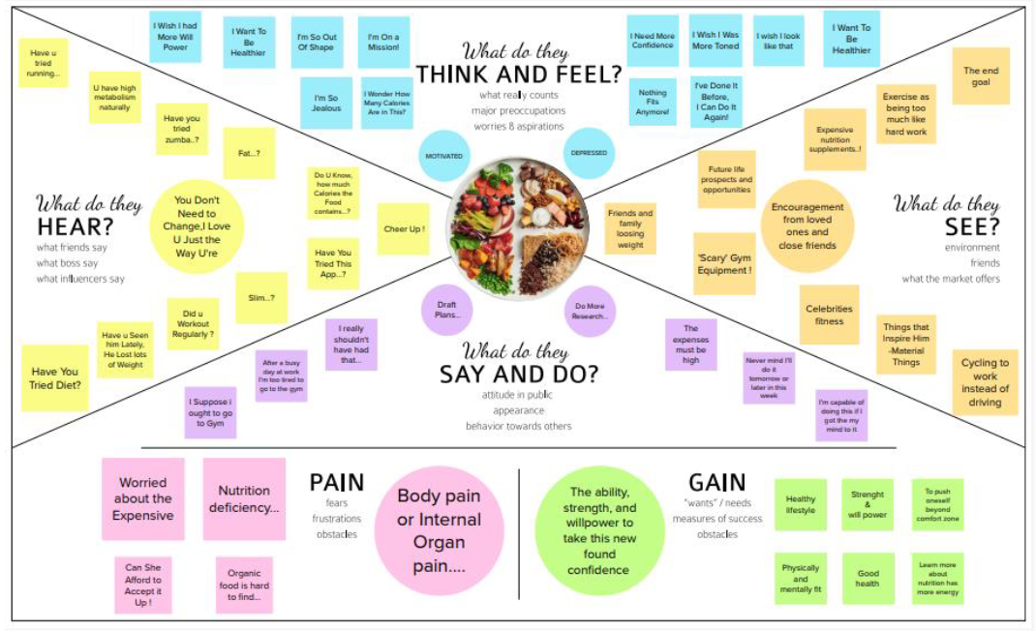

Ideation & Brainstorming

Brainstorming is a method of generating ideas and sharing knowledge to solve a particular commercial or technical problem, in which participants are encouraged to think without interruption. Brainstorming is a group activity where each participant shares their ideas as soon as they come to mind. Everyone in a design team should have a clear definition of the target problem. They typically gather for a brainstorming session in a room with a large board/wall for pictures/PostIts. A good mix of participants will expand the experience pool and therefore broaden the idea space.

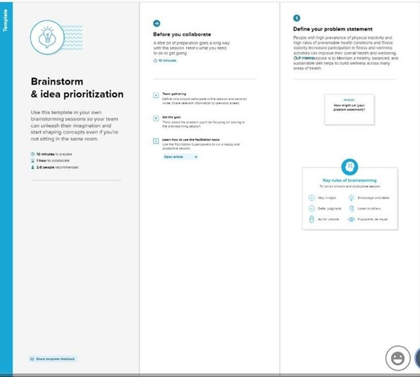

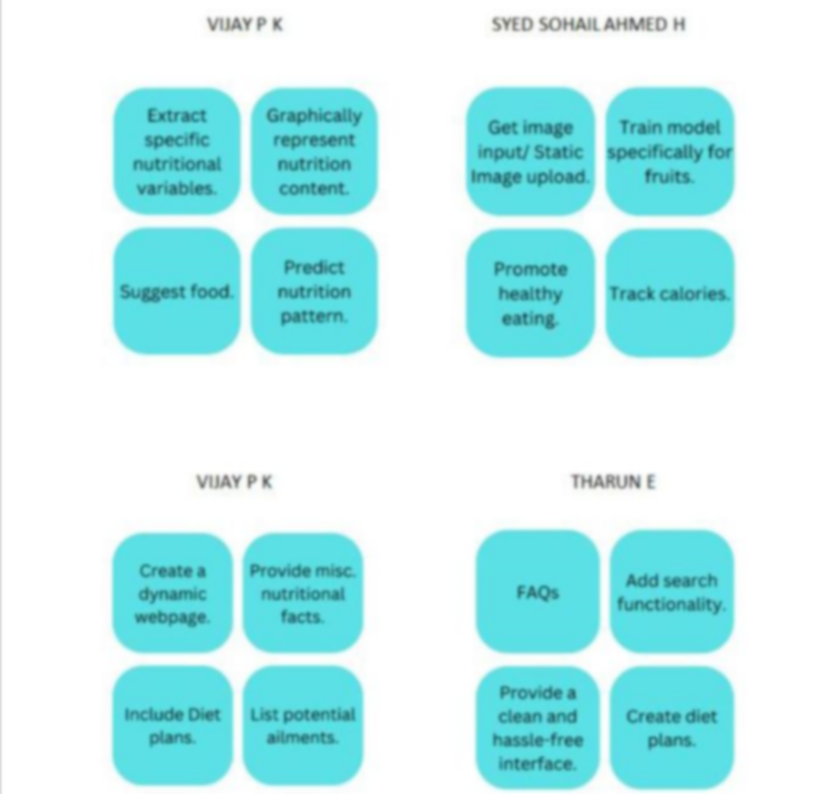

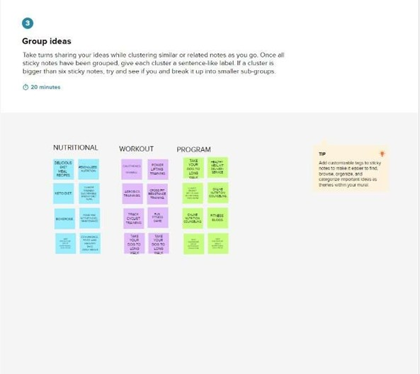

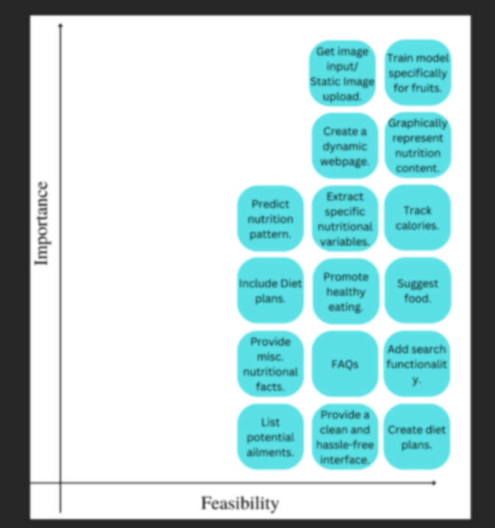

Proposed Solution

S.No. | Parameter | Description
1. | Problem Statement (Problem to be solved) | People are not consuming sufficient amount of food to provide them with the necessary calories, fats, proteins, vitamins and minerals for them to maintain an optimal health. While on the other hand, a section of people consume food that’s plentiful than needed for them.
2. | Idea / Solution description | The main aim of this Nutrition Analyzer is to determine the perfect amount of nutrition needed for the user and for doing so it gives precise measurements of the nutrient contents of the food they consume.
3. | Novelty / Uniqueness | This is available as both webpage and as an application for users convenient with easy accessibility. It makes sure that the user’s water intake is up to their requirement along with the nutrition intake.
4. | Social Impact / Customer Satisfaction | Not every people can afford a nutritionist, but this Analyzer gives them access to explore their nutrition journey. By monitoring the nutrition disorders related to it can be considerably reduced.
5. | Business Model (Revenue Model) | The application can be deployed for access by the general public. The application would draw the attention of several users who are determined to lead a healthy lifestyle and wish to undergo a physical transformation. The application could be built in such a way that features are progressively unlocked based on the subscription amount paid by the user starting from the generic nutrition analyzer feature to charting out personal plans for users.
6. | Scalability of the Solution | The proposed application hasseveral features. It can be further enhanced to integrate more features based on feedback from users and ratings.

  - Problem Solution fit

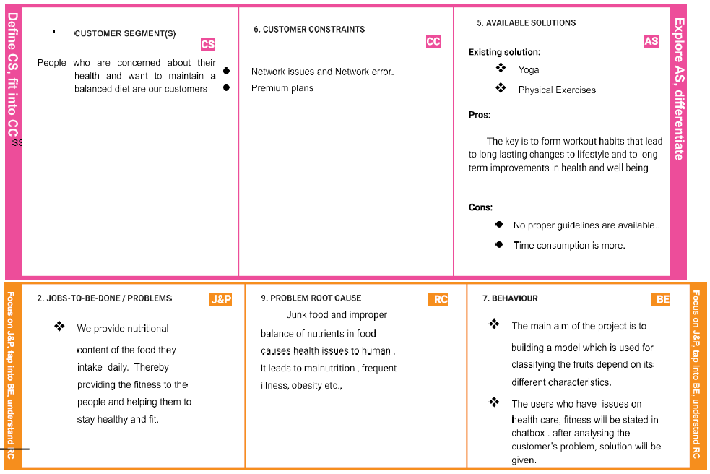

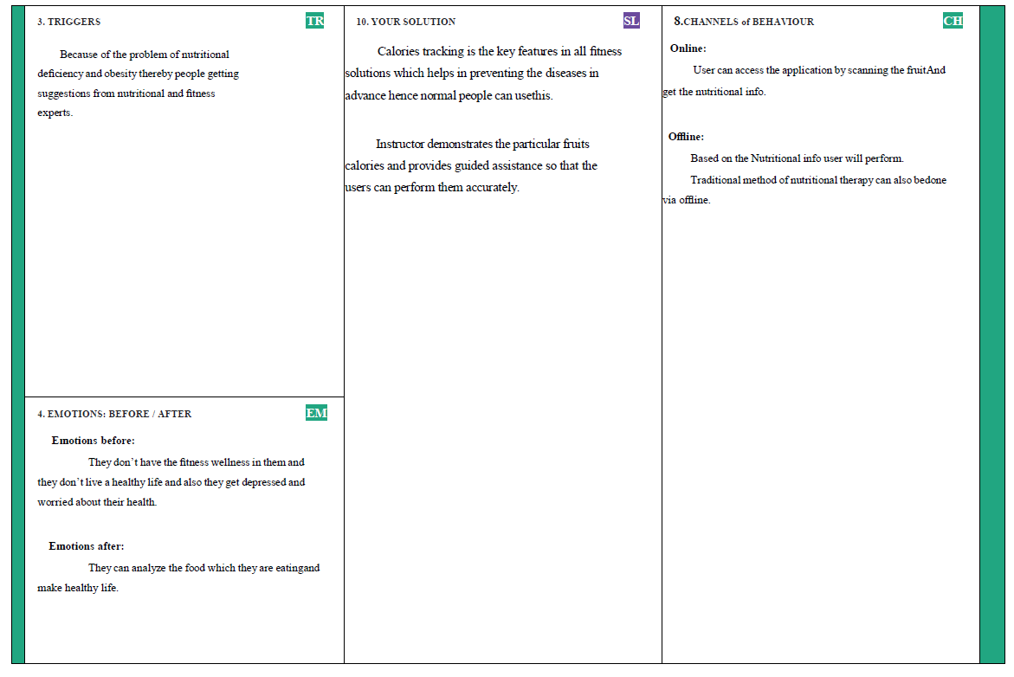

REQUIREMENT ANALYSIS 4.1Functional requirements
To develop this project we need to install the following software/packages:

Anaconda Navigator
Anaconda Navigator is a free and open-source distribution of the python and R programming languages for data science and machine learning-related applications. It can be installed on Windows, Linux, and macOS .Conda is an open-source, cross-platform, package management system, Anaconda comes with great tools like Jupiter Lab, Jupiter Notebook, Spyder, Orange, R studio,Visual Studio Code.

Flask
Web framework used for building web applications. For anaconda navigator, follow the below steps to download the required packages open anaconda prompt as administrator. If you are using Pycharm IDE, you can install the packages through the command prompt and follow the same syntax as above.

Python packages

  - Open anaconda prompt as administrator
  - Type “pip install num py” and click enter.
  - Type “pip install pandas” and click enter.
  - Type “pip install scikit-learn” and click enter.
  - Type “pip install tensorflow==2.3.0” and click enter.
  - Type “pip install keras==2.4.0” and click enter.
  - Type “pip install Flask” and click enter.

- Deep learning concepts

It is a subset of machine learning, deep learning algorithms are perhaps best
exemplified by multi-layer neural networks (NN), which uses multi-layer neural networks to get an idea of imputed unsorted data based on learnt in its. Uses basics concepts from brain biology. Useful when there is a quality of input data.

- Artificial Neural Networks

ANN is an efficient computing system whose central them is borrowed from the
analogy of biological neural networks. ANN is a real so named as “artificial neural systems”, or parallel distributed systems”, or “connectional systems”. ANN acquires a large collection of units that are interconnected in some pattern to allow communication between the units. These units, also referred to as nodes or neurons, are simple processors which operate in parallel.

• Convolution Neural Networks
A convolutional neural network is a class of deep neural networks, most commonly applied to analysing visual imagery. The construction of convolutional neural network is a multi- layered feed-forward neural network, made by assembling many unseen layers on top of each other in a particular order. It is the sequential design that gives permission to CNN to learn hierarchical attributes. In CNN, some of them are followed by grouping layers and hidden layers

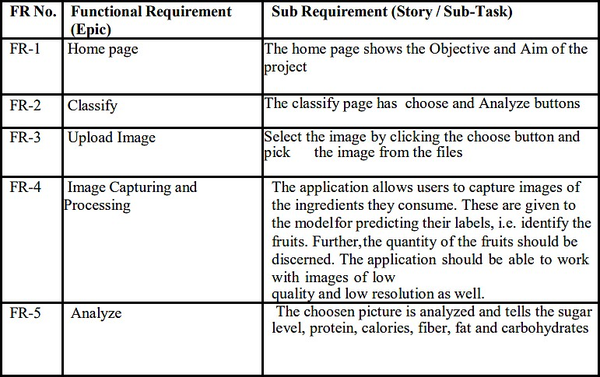

4.2 Non-Functional requirements
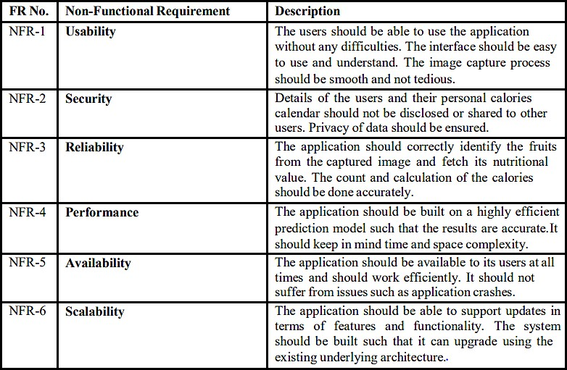

PROJECT DESIGN

Data Flow Diagrams

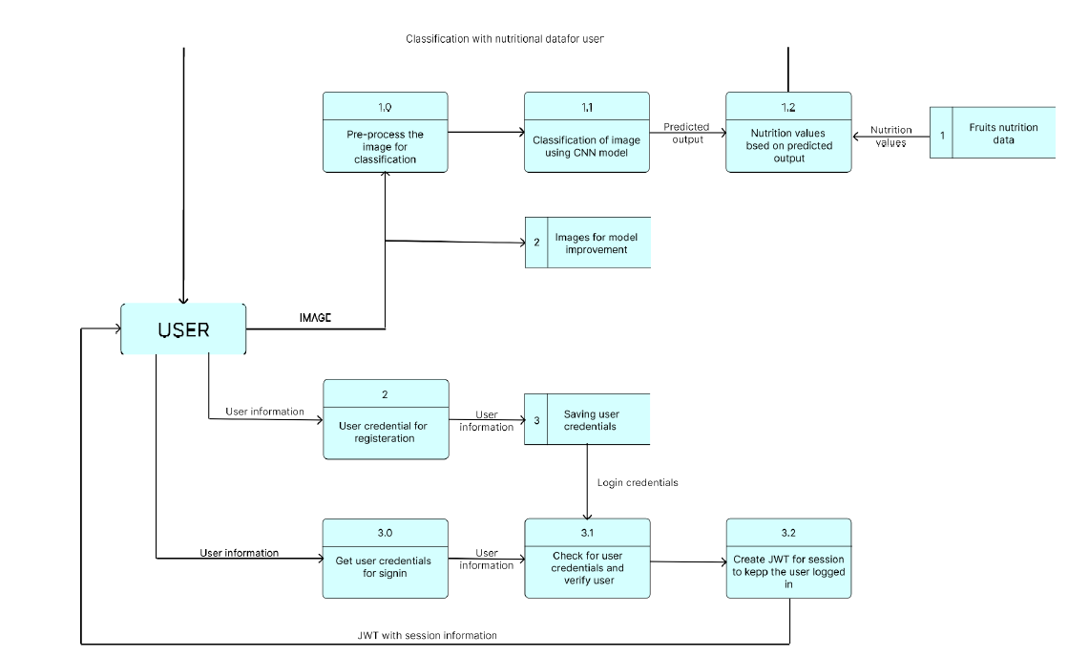

  - Solution & Technical Architecture

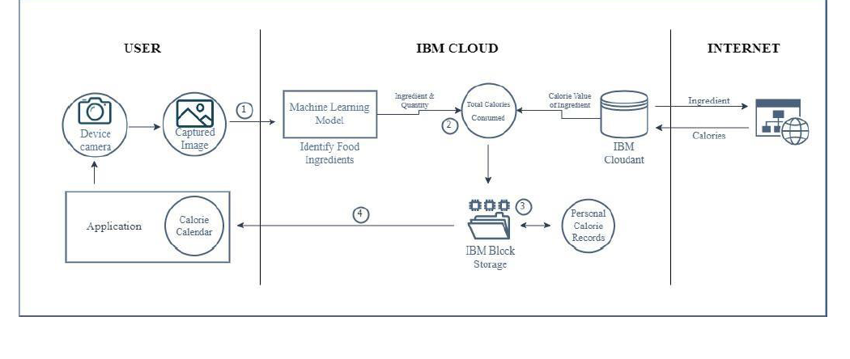

User Stories

A user story is an informal, general explanation of a software feature written from the perspective of the end user. Its purpose is to articulate how a software feature will provide value to the customer. It's tempting to think that user stories are, simply put, software system requirements. But they're not.
A key component of agile software development is putting people first, and a user story puts end users at the center of the conversation. These stories use non-technical language to provide context for the development team and their efforts. After reading a user story, the team knows why they are building, what they're building, and what value it creates. User stories are one of the core components of an agile program. They help provide a user-focused framework for daily work — which drives collaboration, creativity, and a better product overall.

PROJECT PLANNING & SCHEDULING

Sprint Planning & Estimation

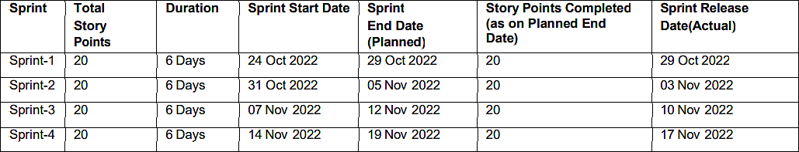

  - Sprint Delivery Schedule

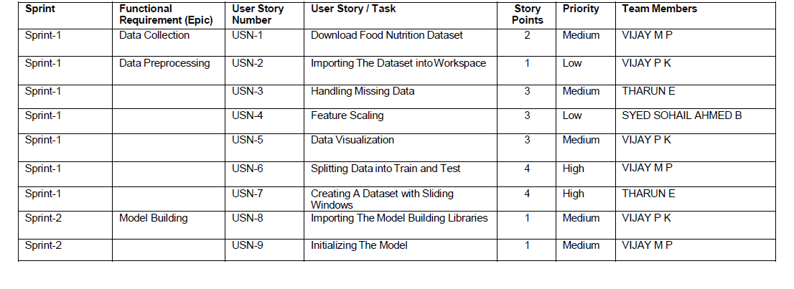

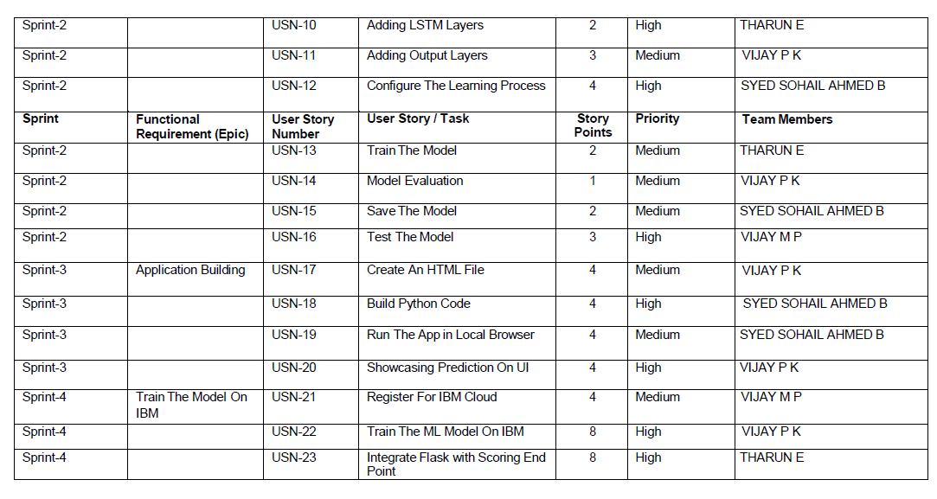

CODING & SOLUTIONING

Features:

DATA COLLECTION:

from google.colab import drive drive.mount('/content/drive') Mounted at /content/drive cd/content/drive/MyDrive/Colab Notebooks
/content/drive/MyDrive/Colab Notebooks

# Unzipping the dataset
!unzip 'Dataset.zip'
Streaming output truncated to the last 5000 lines.

inflating: Dataset/TEST_SET/APPLES/n07740461_13800.jpg inflating: Dataset/TEST_SET/APPLES/n07740461_13851.jpg inflating: Dataset/TEST_SET/APPLES/n07740461_13901.jpg

Image Preprocessing

#Importing The ImageDataGenerator Library
from keras.preprocessing.image import ImageDataGenerator

Image Data Augmentation

#Configure ImageDataGenerator Class

train_datagen=ImageDataGenerator(rescale=1./255,shear_range=0.2,zoom_range=0.2,horizont test_datagen=ImageDataGenerator(rescale=1./255)

Applying Image DataGenerator Functionality To Trainset And Testset

#Applying Image DataGenerator Functionality To Trainset And Testset x_train = train_datagen.flow_from_directory(r'/content/Dataset/TRAIN_SET',
target_size=(64, 64),batch_size=5,color_mode='rgb',class_mode='sparse') #Applying Image DataGenerator Functionality To Testset
x_test = test_datagen.flow_from_directory(

r'/content/Dataset/TEST_SET',
target_size=(64, 64),batch_size=5,color_mode='rgb',class_mode='sparse')

Model Bulding

- Importing The Model Building Libraries
import numpy as np import tensorflow as tf
from tensorflow.keras.models import Sequential from tensorflow.keras import layers from tensorflow.keras.layers import Dense,Flatten
from tensorflow.keras.layers import Conv2D,MaxPooling2D,Dropout

Initializing The Model

model = Sequential()

Adding CNN Layers

# Initializing the CNN
classifier = Sequential()

# First convolution layer and pooling
classifier.add(Conv2D(32, (3, 3), input_shape=(64, 64, 3), activation='relu'))
classifier.add(MaxPooling2D(pool_size=(2, 2)))

# Second convolution layer and pooling classifier.add(Conv2D(32, (3, 3), activation='relu'))

# input_shape is going to be the pooled feature maps from the previous convolution layer classifier.add(MaxPooling2D(pool_size=(2, 2)))

# Flattening the layers classifier.add(Flatten())

Adding Dense Layers

classifier.add(Dense(units=128, activation='relu')) classifier.add(Dense(units=5, activation='softmax')) #summary of our model
classifier.summary()

===============================================================
==
Total params: 813,733
Trainable params: 813,733
Non-trainable params: 0

Configure The Learning Process

# Compiling the CNN
# categorical_crossentropy for more than 2
classifier.compile(optimizer='adam', loss='sparse_categorical_crossentropy', metrics

Train The Model

#Fitting the model
classifier.fit_generator(generator=x_train,steps_per_epoch = len(x_train),epochs=20, valid

#Fitting the model classifier.fit_generator(generator=x_train,steps_per_epoch = len(x_train),epochs=20, valid Epoch 1/20 /usr/local/lib/python3.7/dist-packages/ipykernel_launcher.py:2: UserWarning: `Model. 824/824 [==============================] Epoch 2/20 - 21s 16ms/step - loss: 0.6172 - accuracy: 824/824 [==============================] - 13s 15ms/step - loss: 0.4115 - accuracy: Epoch 3/20 824/824 [==============================] - 13s 16ms/step -
loss: 0.3766 - accuracy: Epoch 4/20 824/824 [==============================] - 13s 16ms/step
- loss: 0.3484 - accuracy: Epoch 5/20 824/824 [==============================] Epoch 6/20 - 13s 16ms/step - loss: 0.3243 - accuracy: 824/824 [==============================] - 13s
16ms/step - loss: 0.3240 - accuracy: Epoch 7/20 824/824 [==============================] -
13s 16ms/step - loss: 0.2887 - accuracy: Epoch 8/20 824/824 [==============================]
- 13s 16ms/step - loss: 0.2728 - accuracy: Epoch 9/20 824/824 [==============================] - 13s 16ms/step - loss: 0.2717 - accuracy: Epoch 10/20 824/824 [==============================] - 14s 17ms/step - loss: 0.2365 - accuracy: Epoch
11/20 824/824 [==============================] - 13s 15ms/step - loss: 0.2301 - accuracy: Epoch 12/20 824/824 [==============================] - 13s 15ms/step - loss: 0.2083 -
accuracy: Epoch 13/20 824/824 [==============================] - 13s 15ms/step - loss: 0.2049 - accuracy: Epoch 14/20 824/824 [==============================] - 12s 15ms/step - loss: 0.1930 - accuracy: Epoch 15/20 824/824 [==============================] - 13s
15ms/step - loss: 0.1807 - accuracy: Epoch 16/20 824/824 [==============================] - 13s 15ms/step - loss: 0.1712 - accuracy: Epoch 17/20 824/824 [==============================] - 13s 15ms/step - loss: 0.1599 - accuracy: Epoch 18/20 824/824 [==============================] - 13s 15ms/step - loss: 0.1619 - accuracy: Epoch
19/20 824/824 [==============================] - 13s 15ms/step - loss: 0.1505 - accuracy: Epoch 20/20 824/824 [==============================] - 12s 15ms/step - loss: 0.1211 -
accuracy:

Saving The Model

classifier.save('nutrition.h5')

Testing The Model

#Predict the results
from tensorflow.keras.models

import load_model from keras.preprocessing import image model = load_model("nutrition.h5")
from tensorflow.keras.utils import img_to_array

#loading of the image

img = load_img(r'/content/Sample_Images/Test_Image1.jpg',grayscale=False,target_size= (64, 64)
#image to array

x = img_to_array(img) #changing the shape
x = np.expand_dims(x,axis = 0)

predict_x=model.predict(x) classes_x=np.argmax(predict_x,axis=-1) classes_x
1/1[==============================] - 0s 18ms/step array([0]) index=['APPLES', 'BANANA', 'ORANGE','PINEAPPLE','WATERMELON']
result=str(index[classes_x[0]])

result 'APPLES

Features:

Python code

from flask import Flask,render_template,request

import os
import numpy as np
from tensorflow.keras.models import load_model from tensorflow.keras.preprocessing import image import requests
app = Flask( name ,template_folder="templates") model=load_model('nutrition.h5')
print("Loaded model from disk")

@app.route('/') def home():
return render_template('home.html')

@app.route('/image1',methods=['GET','POST']) def image1():
return render_template("image.html")

@app.route('/predict',methods=['GET', 'POST']) def launch():
if request.method=='POST':
f=request.files['file'] basepath=os.path.dirname(' file ')
filepath=os.path.join(basepath,"uploads",f.filename) f.save(filepath)

img=image.load_img(filepath,target_size=(64,64)) x=image.img_to_array(img) x=np.expand_dims(x,axis=0)

pred=np.argmax(model.predict(x), axis=1) print("prediction",pred)
index=['APPLES','BANANA','ORANGE','PINEAPPLE','WATERMELON']

result=str(index[pred[0]]) x=result
print(x)
result=nutrition(result) print(result)

return render_template("0.html",showcase=(result),showcase1=(x)) def nutrition(index):
url = "https://calorieninjas.p.rapidapi.com/v1/nutrition" querystring = {"query": "tomato"}
headers = {
"X-RapidAPI-Key": "f2179b0ee2msh46dd220682815e1p1e6122jsnaea9bb30dd96", "X-RapidAPI-Host": "calorieninjas.p.rapidapi.com"
}
response = requests.request("GET", url, headers=headers, params=querystring) print(response.text)
return response.json()['items'] if name == " main ":

app.run(debug=True

Html pages 0.HTML
<html lang="en" dir="ltr">
<head>
<style>

</style>
<meta charset="utf-8">
<title>NUTRITION IMAGE ANALYSIS</title>
<link rel="shortcut icon" href="{{ url_for('static', filename='diabetes-favicon.ico') }}">
<link rel="stylesheet" type="text/css" href="{{ url_for('static', filename='style.css') }}">
<script src="https://kit.fontawesome.com/5f3f547070.js" crossorigin="anonymous"></script>

Home.HTML
<link href="https://fonts.googleapis.com/css2?family=Pacifico&display=swap" rel="stylesheet">
</head>

<div class="results">
<p style="padding-top: 150px; color:blue;"><h4 style="color:blue;">IMAGE CLASSIFIED IS :
<h4><b><h4 style="color:red;"><u>{{showcase1}}<h4><br><h4 style="color:red;"><u>{{showcase}}<h4></p>

</div>
<br>
<br>

</div>
</body>
</html

<!DOCTYPE html>
<html>
<head>
<meta charset="UTF-8">
<meta name="viewport" content="width=device-width, initial-scale=1.0">
<meta http-equiv="X-UA-Compatible" content="ie=edge">
<title>HOME</title>
<link rel="stylesheet" href="https://cdnjs.cloudflare.com/ajax/libs/font-awesome/4.7.0/css/font- awesome.min.css">
<link href="https://cdn.bootcss.com/bootstrap/4.0.0/css/bootstrap.min.css" rel="stylesheet">
<script src="https://cdn.bootcss.com/popper.js/1.12.9/umd/popper.min.js"></script>
<script src="https://cdn.bootcss.com/jquery/3.3.1/jquery.min.js"></script>
<script src="https://cdn.bootcss.com/bootstrap/4.0.0/js/bootstrap.min.js"></script>
<link href="{{ url_for('static', filename='css/main.css') }}" rel="stylesheet">
</head>
<body>

<!--Brian Tracy-->

<div class="header">
<div style="width:50%;float:left;font-size:2vw;text-align:left;color:black; padding-top:1%;padding- left:5%;">NUTRITION IMAGE ANALYSIS</div>
<div class="topnav-right"style="padding-top:0.5%;">

<a class="active" href="{{ url_for('home')}}"><b>HOME</b></a>
<a href="{{ url_for('image1')}}"><b>CLASSIFY</b></a>
</div>
</div>

</div>
<br>
<br>

<section id="about">
<div class="container mt-4 pt-4">
<br><br><br>
<h1 class="text-center"><center><b>&emsp;OBJECTIVE OF THE PROJECT</center></b></h1>
<div class="row mt-4">
<div class="col-lg-4">
<img src="https://cdn.pixabay.com/photo/2017/05/07/19/32/strawberry-2293337_960_720.jpg" class= "imageAboutPage"alt="">
</div>

<div class="col-lg-8">
<br>

<ul>
<li>Food is essential for human life and has been the concern of many healthcare conventions. </li>
<li>Nowadays new dietary assessment and nutrition analysis tools enable more opportunities to help people understand their daily eating habits, exploring nutrition patterns and maintain a healthy diet. </li>
<li>Nutritional analysis is the process of determining the nutritional content of food. </li>
<li>It is a vital part of analytical chemistry that provides information about the chemical composition, processing, quality control and contamination of food.</li>
</ul>

</div>
</div>
</section>
<br>
<br>
<br><br>
<section id="about">
<div class="container mt-4 pt-4">
<br><br><br>
<h1 class="text-center"><b>AIM OF THE PROJECT</b></h1>
<div class="row mt-4">
<div class="col-lg-4">
<img src="https://www.cdc.gov/foodsafety/images/comms/features/GettyImages-1247930626- 500px.jpg?_=00453" class= "imageAboutPage" alt="">
</div>

<div class="col-lg-8">
<br>
<ul>
<li>The main aim of the project is to building a model which is used for classifying the fruit depends on the different characteristics like colour, shape, texture etc. </li>
<li>Here the user can capture the images of different fruits and then the image will be sent the trained model.</li>
<li>The model analyses the image and detect the nutrition based on the fruits like (Sugar, Fibre, Protein, Calories, etc.).</li>
</ul>
</div>
</div>
</section>
<br>
<br>
<br>
<br>
<br>
</body>
</html>

- TESTING

Test Cases

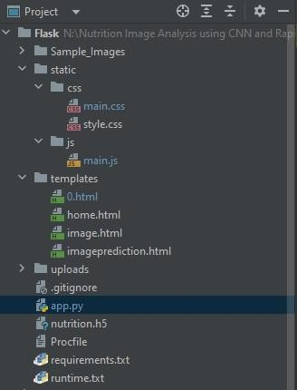

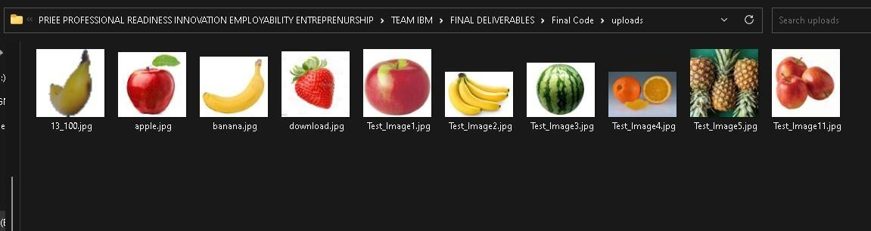

  - User Acceptance Testing
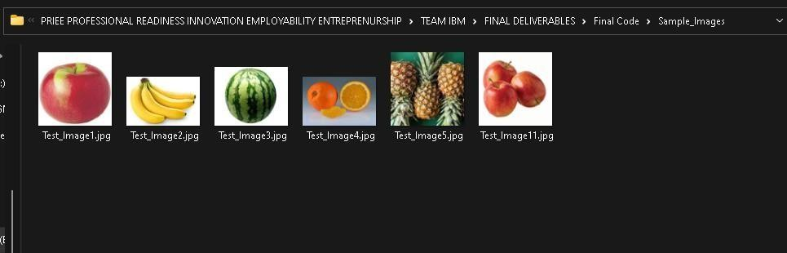

RESULTS

Performance Metrics
    - Confusion Matrix
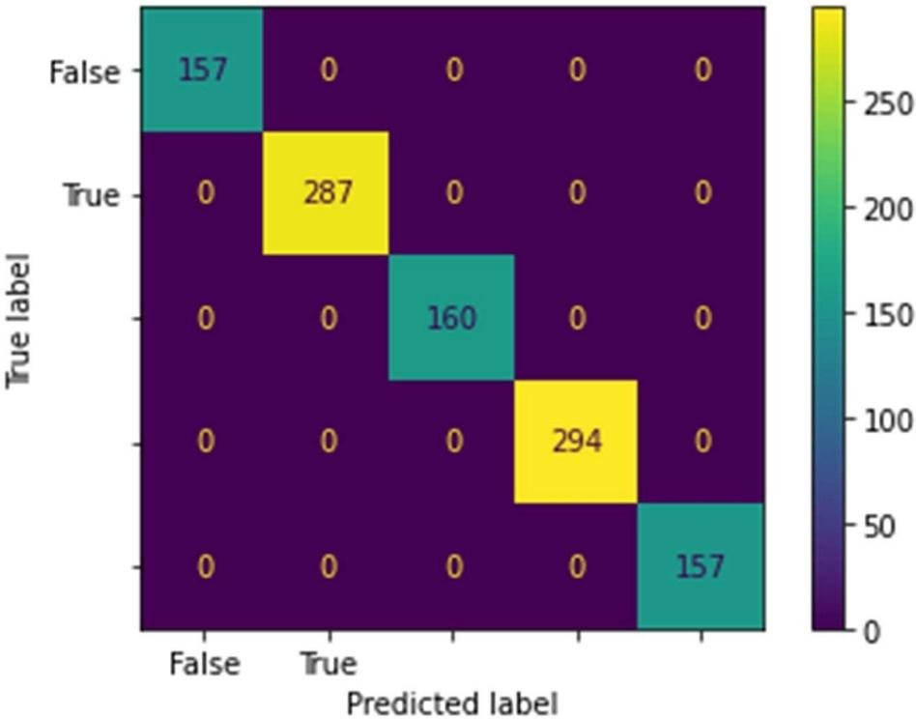

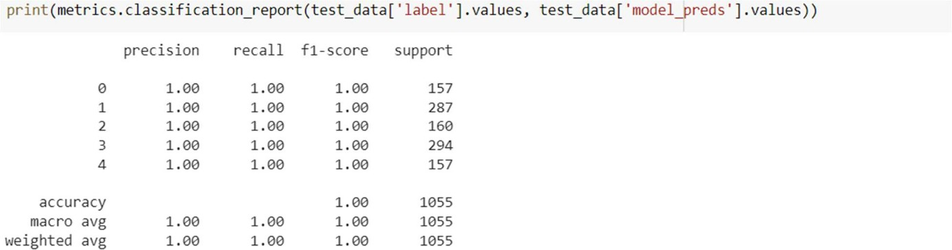

    - Accuracy – 100 %
    - Precision – 100 %
    - Recall – 100 %

    - Specificity – 100 %

6.F1-Score – 100 %

  - Output Screenshot

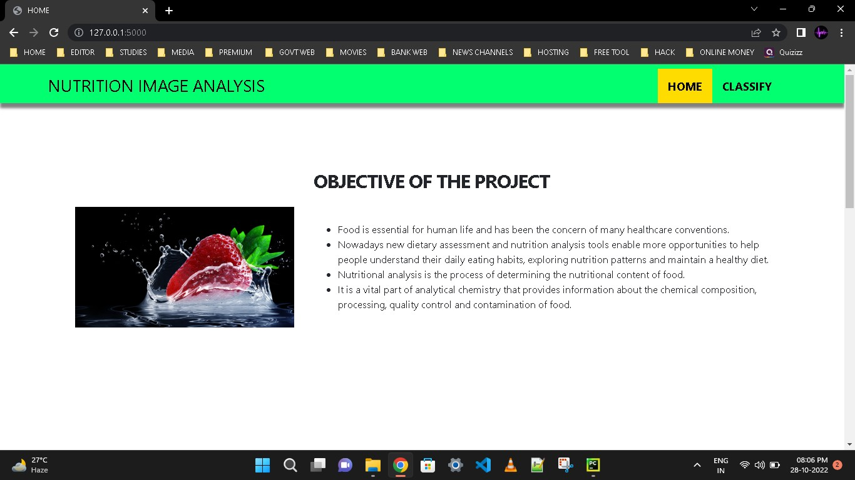

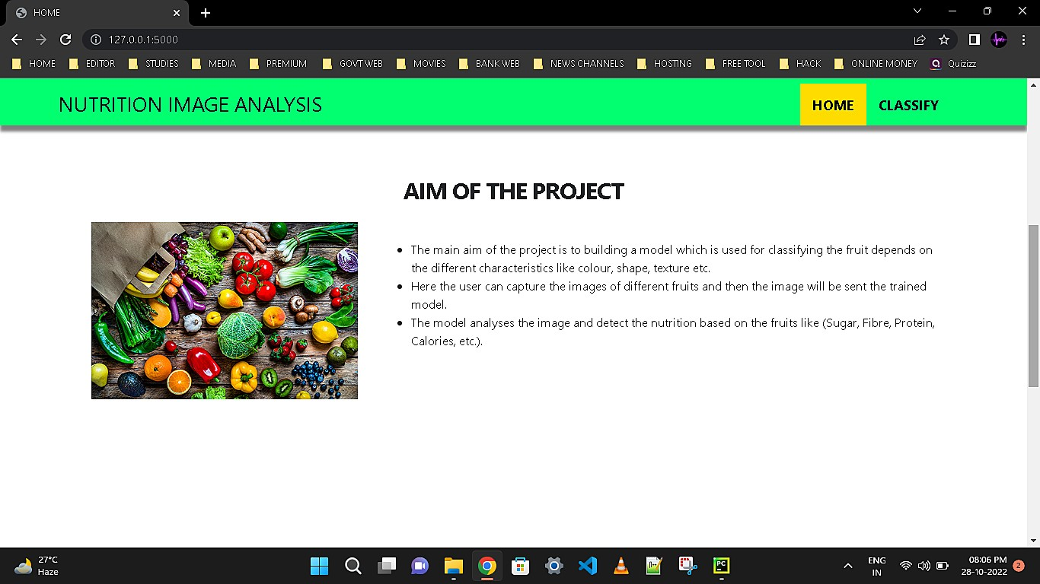

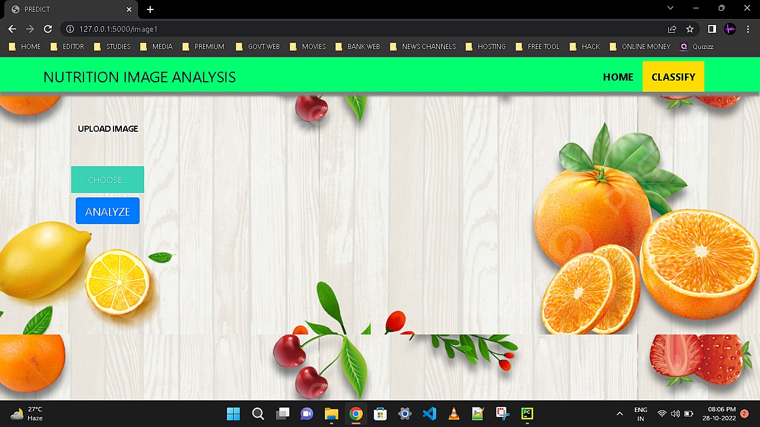

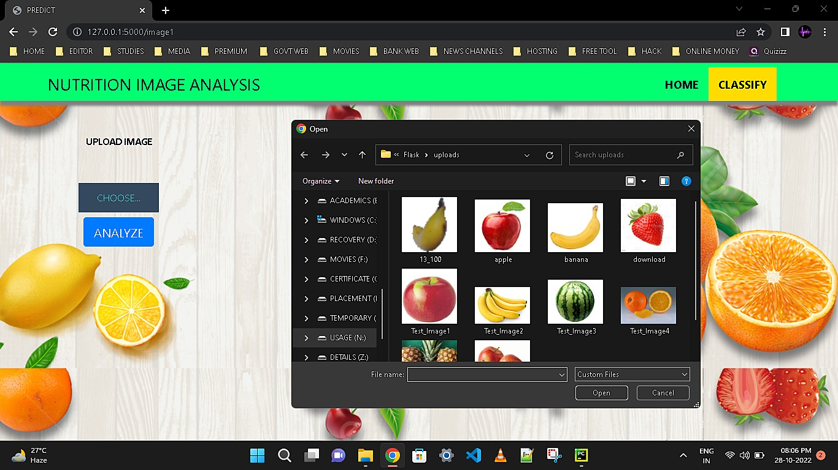
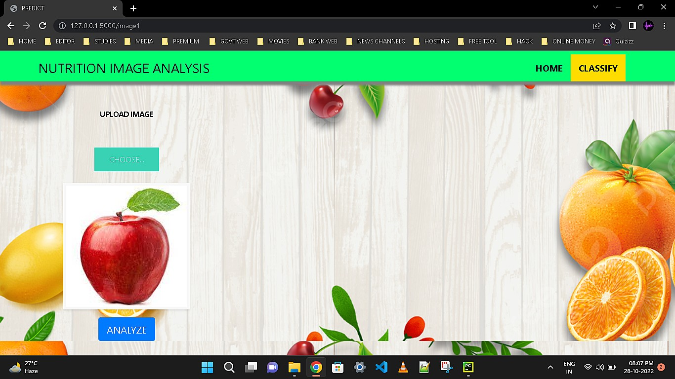

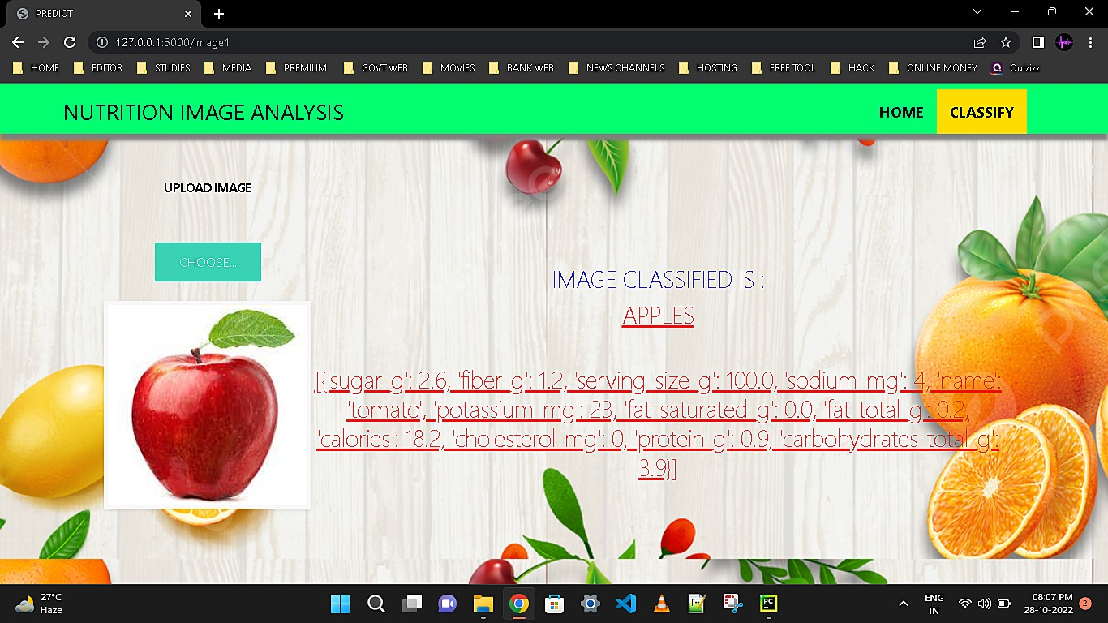

ADVANTAGES & DISADVANTAGES

ADVANTAGES

- Food pattern is an important factor to prevent diseases and improve lifestyle. Studies show that changes in diet affect the evolution of chronic non-communicable diseases (CNCD) like cardiovascular diseases, obesity, and depression. It is highly recommended to change eating habits to prevent non-communicable diseases. Artificial Intelligence in nutrition is becoming popular for prevention and treatment.

- Analysis of personal health metrics has become possible because of advances in Artificial Intelligence.

- While artificial intelligence is increasing its part in our daily lives, AI-based diet planning could be created where it will be dependent on user’s data and machine learning to create a comprehensive meal plan for every user based on their actual metabolic need.

DISADVANTAGES

- If the dataset has not been properly uploaded ,then the detection of images can be difficult.
- If the images are not clear, the nutrition analysis can be difficult.
- The user’s health condition are not described.

CONCLUSION

Thus the AI powered nutrition analyzer for fitness enthusiasts has been implemented. Presented system includes a home page and classify page respectively.In the home page,The aim and objective of the project has been provided. In the classify page,the user has to upload the image of the food and click the classify option .The various nutritions present in the image will be provided.With this project we will analyze the image and nutrients has been provided as output.

FUTURE SCOPE

There are some other ongoing efforts in the field as well. In certain nutrition studies, smartphone photos of individuals’ plates of food are being analyzed by deep learning, a subtype of Artificial Intelligence, to streamline the food logging process as well as eliminating the risk of human error. However, for obtaining a comprehensive data set, factors like activity levels, sleep patterns, medication consumption, and microbiome functioning require to be integrated into the data set. This can be achieved via the implementation of advanced algorithms that track the important health metrics for the development of a personalized diet.

APPENDIX

Source Code

DATA COLLECTION:

from google.colab import drive drive.mount('/content/drive') Mounted at /content/drive cd/content/drive/MyDrive/Colab Notebooks
/content/drive/MyDrive/Colab Notebooks

# Unzipping the dataset
!unzip 'Dataset.zip'
Streaming output truncated to the last 5000 lines.

inflating: Dataset/TEST_SET/APPLES/n07740461_13800.jpg inflating: Dataset/TEST_SET/APPLES/n07740461_13851.jpg inflating: Dataset/TEST_SET/APPLES/n07740461_13901.jpg

Image Preprocessing

#Importing The ImageDataGenerator Library
from keras.preprocessing.image import ImageDataGenerator

Image Data Augmentation

#Configure ImageDataGenerator Class

train_datagen=ImageDataGenerator(rescale=1./255,shear_range=0.2,zoom_range=0.2,horizont test_datagen=ImageDataGenerator(rescale=1./255)

Applying Image DataGenerator Functionality To Trainset And Testset

#Applying Image DataGenerator Functionality To Trainset And Testset x_train = train_datagen.flow_from_directory(r'/content/Dataset/TRAIN_SET',
target_size=(64, 64),batch_size=5,color_mode='rgb',class_mode='sparse') #Applying Image DataGenerator Functionality To Testset
x_test = test_datagen.flow_from_directory( r'/content/Dataset/TEST_SET',
target_size=(64, 64),batch_size=5,color_mode='rgb',class_mode='sparse')

Model Bulding

- Importing The Model Building Libraries
import numpy as np import tensorflow as tf
from tensorflow.keras.models import Sequential from tensorflow.keras import layers from tensorflow.keras.layers import Dense,Flatten
from tensorflow.keras.layers import Conv2D,MaxPooling2D,Dropout

Initializing The Model

model = Sequential()

Adding CNN Layers

# Initializing the CNN
classifier = Sequential()

# First convolution layer and pooling
classifier.add(Conv2D(32, (3, 3), input_shape=(64, 64, 3), activation='relu'))
classifier.add(MaxPooling2D(pool_size=(2, 2)))

# Second convolution layer and pooling classifier.add(Conv2D(32, (3, 3), activation='relu'))

# input_shape is going to be the pooled feature maps from the previous convolution layer classifier.add(MaxPooling2D(pool_size=(2, 2)))

# Flattening the layers classifier.add(Flatten())

Adding Dense Layers

classifier.add(Dense(units=128, activation='relu')) classifier.add(Dense(units=5, activation='softmax')) #summary of our model
classifier.summary()

===============================================================
==
Total params: 813,733
Trainable params: 813,733
Non-trainable params: 0

Configure The Learning Process

# Compiling the CNN
# categorical_crossentropy for more than 2
classifier.compile(optimizer='adam', loss='sparse_categorical_crossentropy', metrics

Train The Model

#Fitting the model
classifier.fit_generator(generator=x_train,steps_per_epoch = len(x_train),epochs=20, valid

#Fitting the model classifier.fit_generator(generator=x_train,steps_per_epoch = len(x_train),epochs=20, valid Epoch 1/20 /usr/local/lib/python3.7/dist-packages/ipykernel_launcher.py:2: UserWarning: `Model. 824/824 [==============================] Epoch 2/20 - 21s 16ms/step - loss: 0.6172 - accuracy: 824/824 [==============================] - 13s 15ms/step - loss: 0.4115 - accuracy: Epoch 3/20 824/824 [==============================] - 13s 16ms/step -
loss: 0.3766 - accuracy: Epoch 4/20 824/824 [==============================] - 13s 16ms/step
- loss: 0.3484 - accuracy: Epoch 5/20 824/824 [==============================] Epoch 6/20 -

13s 16ms/step - loss: 0.3243 - accuracy: 824/824 [==============================] - 13s
16ms/step - loss: 0.3240 - accuracy: Epoch 7/20 824/824 [==============================] -
13s 16ms/step - loss: 0.2887 - accuracy: Epoch 8/20 824/824 [==============================]
- 13s 16ms/step - loss: 0.2728 - accuracy: Epoch 9/20 824/824 [==============================] - 13s 16ms/step - loss: 0.2717 - accuracy: Epoch 10/20 824/824 [==============================] - 14s 17ms/step - loss: 0.2365 - accuracy: Epoch
11/20 824/824 [==============================] - 13s 15ms/step - loss: 0.2301 - accuracy: Epoch 12/20 824/824 [==============================] - 13s 15ms/step - loss: 0.2083 -
accuracy: Epoch 13/20 824/824 [==============================] - 13s 15ms/step - loss: 0.2049 - accuracy: Epoch 14/20 824/824 [==============================] - 12s 15ms/step - loss: 0.1930 - accuracy: Epoch 15/20 824/824 [==============================] - 13s
15ms/step - loss: 0.1807 - accuracy: Epoch 16/20 824/824 [==============================] - 13s 15ms/step - loss: 0.1712 - accuracy: Epoch 17/20 824/824 [==============================] - 13s 15ms/step - loss: 0.1599 - accuracy: Epoch 18/20 824/824 [==============================] - 13s 15ms/step - loss: 0.1619 - accuracy: Epoch
19/20 824/824 [==============================] - 13s 15ms/step - loss: 0.1505 - accuracy: Epoch 20/20 824/824 [==============================] - 12s 15ms/step - loss: 0.1211 -
accuracy:

Saving The Model

classifier.save('nutrition.h5')

Testing The Model

#Predict the results
from tensorflow.keras.models

import load_model from keras.preprocessing import image model = load_model("nutrition.h5")
from tensorflow.keras.utils import img_to_array

#loading of the image

img = load_img(r'/content/Sample_Images/Test_Image1.jpg',grayscale=False,target_size= (64, 64)

#image to array
x = img_to_array(img) #changing the shape
x = np.expand_dims(x,axis = 0)

predict_x=model.predict(x) classes_x=np.argmax(predict_x,axis=-1) classes_x
1/1[==============================] - 0s 18ms/step array([0]) index=['APPLES', 'BANANA', 'ORANGE','PINEAPPLE','WATERMELON']
result=str(index[classes_x[0]]) result 'APPLES

Python code

from flask import Flask,render_template,request

import os
import numpy as np
from tensorflow.keras.models import load_model from tensorflow.keras.preprocessing import image import requests

app = Flask( name ,template_folder="templates")

model=load_model('nutrition.h5') print("Loaded model from disk")

@app.route('/') def home():
return render_template('home.html')

@app.route('/image1',methods=['GET','POST']) def image1():
return render_template("image.html")

@app.route('/predict',methods=['GET', 'POST']) def launch():
if request.method=='POST': f=request.files['file'] basepath=os.path.dirname(' file ')
filepath=os.path.join(basepath,"uploads",f.filename) f.save(filepath)

img=image.load_img(filepath,target_size=(64,64)) x=image.img_to_array(img) x=np.expand_dims(x,axis=0)

pred=np.argmax(model.predict(x), axis=1) print("prediction",pred)
index=['APPLES','BANANA','ORANGE','PINEAPPLE','WATERMELON']

result=str(index[pred[0]])

x=result print(x)
result=nutrition(result) print(result)

return render_template("0.html",showcase=(result),showcase1=(x)) def nutrition(index):
url = "https://calorieninjas.p.rapidapi.com/v1/nutrition" querystring = {"query": "tomato"}
headers = {
"X-RapidAPI-Key": "f2179b0ee2msh46dd220682815e1p1e6122jsnaea9bb30dd96", "X-RapidAPI-Host": "calorieninjas.p.rapidapi.com"
}
response = requests.request("GET", url, headers=headers, params=querystring) print(response.text)
return response.json()['items'] if name == " main ":

app.run(debug=True

Html pages 0.HTML
<html lang="en" dir="ltr">
<head>
<style>

</style>
<meta charset="utf-8">
<title>NUTRITION IMAGE ANALYSIS</title>
<link rel="shortcut icon" href="{{ url_for('static', filename='diabetes-favicon.ico') }}">
<link rel="stylesheet" type="text/css" href="{{ url_for('static', filename='style.css') }}">
<script src="https://kit.fontawesome.com/5f3f547070.js" crossorigin="anonymous"></script>
<link href="https://fonts.googleapis.com/css2?family=Pacifico&display=swap" rel="stylesheet">
</head>

Home.HTML
<div class="results">
<p style="padding-top: 150px; color:blue;"><h4 style="color:blue;">IMAGE CLASSIFIED IS :
<h4><b><h4 style="color:red;"><u>{{showcase1}}<h4><br><h4 style="color:red;"><u>{{showcase}}<h4></p>

</div>
<br>
<br>

</div>
</body>
</html

<!DOCTYPE html>
<html>
<head>
<meta charset="UTF-8">
<meta name="viewport" content="width=device-width, initial-scale=1.0">
<meta http-equiv="X-UA-Compatible" content="ie=edge">
<title>HOME</title>
<link rel="stylesheet" href="https://cdnjs.cloudflare.com/ajax/libs/font-awesome/4.7.0/css/font- awesome.min.css">
<link href="https://cdn.bootcss.com/bootstrap/4.0.0/css/bootstrap.min.css" rel="stylesheet">
<script src="https://cdn.bootcss.com/popper.js/1.12.9/umd/popper.min.js"></script>
<script src="https://cdn.bootcss.com/jquery/3.3.1/jquery.min.js"></script>
<script src="https://cdn.bootcss.com/bootstrap/4.0.0/js/bootstrap.min.js"></script>
<link href="{{ url_for('static', filename='css/main.css') }}" rel="stylesheet">
</head>
<body>

<!--Brian Tracy-->

<div class="header">
<div style="width:50%;float:left;font-size:2vw;text-align:left;color:black; padding-top:1%;padding- left:5%;">NUTRITION IMAGE ANALYSIS</div>
<div class="topnav-right"style="padding-top:0.5%;">

<a class="active" href="{{ url_for('home')}}"><b>HOME</b></a>
<a href="{{ url_for('image1')}}"><b>CLASSIFY</b></a>
</div>
</div>
</div>
<br>
<br>

<section id="about">
<div class="container mt-4 pt-4">
<br><br><br>
<h1 class="text-center"><center><b>&emsp;OBJECTIVE OF THE PROJECT</center></b></h1>
<div class="row mt-4">
<div class="col-lg-4">
<img src="https://cdn.pixabay.com/photo/2017/05/07/19/32/strawberry-2293337_960_720.jpg" class= "imageAboutPage"alt="">
</div>

<div class="col-lg-8">
<br>

<ul>
<li>Food is essential for human life and has been the concern of many healthcare conventions. </li>
<li>Nowadays new dietary assessment and nutrition analysis tools enable more opportunities to help people understand their daily eating habits, exploring nutrition patterns and maintain a healthy diet. </li>
<li>Nutritional analysis is the process of determining the nutritional content of food. </li>
<li>It is a vital part of analytical chemistry that provides information about the chemical composition, processing, quality control and contamination of food.</li>
</ul>

</div>
</div>
</section>
<br>
<br>
<br><br>
<section id="about">
<div class="container mt-4 pt-4">
<br><br><br>
<h1 class="text-center"><b>AIM OF THE PROJECT</b></h1>
<div class="row mt-4">
<div class="col-lg-4">
<img src="https://www.cdc.gov/foodsafety/images/comms/features/GettyImages-1247930626- 500px.jpg?_=00453" class= "imageAboutPage" alt="">
</div>

<div class="col-lg-8">
<br>
<ul>

<li>The main aim of the project is to building a model which is used for classifying the fruit depends on the different characteristics like colour, shape, texture etc. </li>
<li>Here the user can capture the images of different fruits and then the image will be sent the trained model.</li>
<li>The model analyses the image and detect the nutrition based on the fruits like (Sugar, Fibre, Protein, Calories, etc.).</li>
</ul>
</div>
</div>
</section>
<br>
<br>
<br>
<br>
<br>
</body>
</html>

Demo Link

https://drive.google.com/file/d/1P9PC6z7GuXqqtQQWfD2TMb-3ZOtvfzuz/view?usp=drivesdk

GitHub Link

https://github.com/IBM-EPBL/IBM-Project-5719-1658813516

